ManualQuote Trade Report

Requirement
- When an incoming order trades against a manual quote order, CBOEdirect sends the trade report to CTMR with all the desired information.
  - For incoming order the trade report has Broker acronym as “XXP”
  - For Manual quote order the origin type is “K”
- When TE sends the trade report to CTMR, the clearing type of the manual quote side is marked as IGNORE so that CTMR would not process this side of the trade report.
- TE sends file report to PAR with Broker acronym of the incoming order as “XXP”
- PAR sends a manual fill report back to TE.
- If PAR is unable to send the manual quote order fill report back to TE for whatever reason, the manual quote trade will remain as unmatched in CTMR.
- No last sale is published for trade with Manual quote order.
- Trade Through is not evaluated for trades with Manual quote order

Design
When a manual quote trades with an incoming order or quote, trade report is generated in two steps.
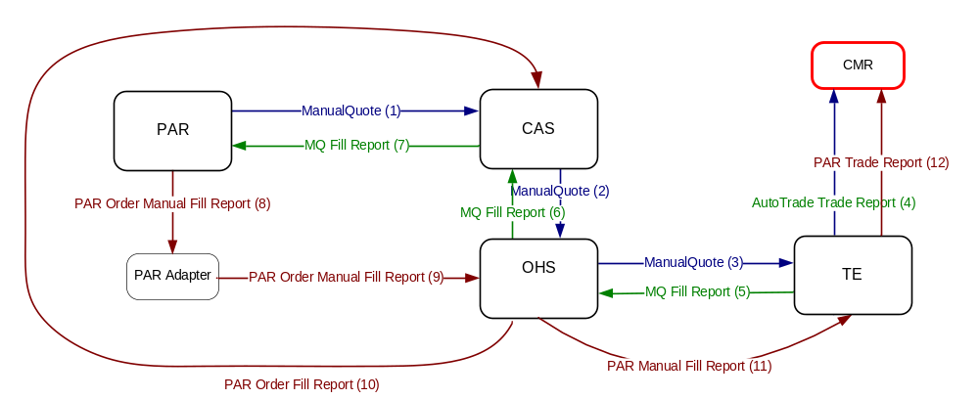

Figure 1. Manual Quote Trade Report

Step 1

The manual quote, resting in book, trades with an incoming order or auto quote at TE. TE will generate a trade report and send it to CTMR. (step 4 in figure 1). This trade report has following features:

- This trade report may contain one or more trade report entries.
- If a trade report entry has one side as manual quote and another side as an order,
  - the clearing type of the manual quote side will be set as “IGNORE”, indicating the manual quote side of the trade will NOT be cleared by CTMR,
  - the broker acronym of the order side will be set as “XXP”
  - the clearing type of the order side will be set as “CLEAR” or whatever it is as in current production, indicating the order side will be processed by CTMR.
- If a trade report entry has one side as manual quote and another side as an auto quote,
  - the clearing type of the manual quote side will be set as “IGNORE”, indicating the manual quote will not be processed by CTMR
  - the broker acronym of the auto quote side will be set as the acronym of the Market Maker who sends this auto quote, as it does today.
  - the clearing type of the auto quote side will be set as “CLEAR”, indicating the auto quote side will be processed by CTMR

In this step, TE also publish last sale and trade through.

In this step, a fill report is sent back to PAR through CAS (step 6 in figure 1) . In this report, the broker acronym of a contra-party of the manual quotes should be “XXP” if the contra-party is an order.

Step 2

After PAR processes the manual quote fill report, received from TE, PAR sends a manual fill report to CBOEDirect. TE processes this manual fill report and generate the second trade report to CTMR (step 12 of figure 1). The second trade report has following features:
- This trade report contain only one trade report entries. One side of the trade report entry is PAR order and the another side is incoming order/quote.
- If a trade report entry has one side as PAR order and another side as order,
  - the clearing type of the PAR order side will be set as “CLEAR”, indicating the PAR order will be processed by CTMR
  - the broker acronym of the order side will be set as “XXP”
  - the clearing type of the order side will be set as “CLEAR”, indicating the order side will NOT be processed by CTMR
- If a trade report entry has one side as PAR order and another side as auto quote,
  - the clearing type of the PAR order side will be set as “CLEAR”, indicating the PAR order will be processed by CTMR,
  - the broker acronym of the auto quote side will be set as the acronym of the Market Maker who sends this auto quote, as it does today.
  - the clearing type of the auto quote side will be set as “IGNORE”, indicating the auto quote side will NOT be processed by CTMR.

In this step, TE will NEITHER publish last sale NONE checking trade through.

Implementation

Code Changes:

- In TE auto-trade trade report, mark manual quote side clearing type as “IGNORE”:
(a) Adding a new method BillingStrategy.setClearingTypeForManualQuote(),which set the clearing type of manual quote side of a TradeReportEntry to IGNORE.

public static void setClearingTypeForManualQuote(
TradeReportEntry tradeReportEntry,
ParticipantItem p_buy,
ParticipantItem p_sell)
{
Tradable buy = p_buy.getParticipantTradable();
Tradable sell = p_sell.getParticipantTradable();

if (isManualQuote(buy))
{
tradeReportEntry.setBuyerClearingType(ClearingTypes.IGNORE);
tradeReportEntry.setBuyerSupressionReason(ClearingTypeFilters.FILTERED_BY_MANUAL_QUOTE);
}

if (isManualQuote(sell))
{
tradeReportEntry.setSellerClearingType(ClearingTypes.IGNORE);
tradeReportEntry.setSellSupressionReason(ClearingTypeFilters.FILTERED_BY_MANUAL_QUOTE);
}
}

(b) Call above new method from AtomicTradeImpl.populateTradeReportEntryData() method.

- In TE auto-trade trade report, mark order side broker acronym as “XXP”:
    - Following existing pattern, add broker acronym for manual quote “XXP” into Order.xml at TE side, (server_properties/xml/Order.xml)
<OrderHomeImplProperties>
......
<anonymousIfNotClearsLikeQuoteBroker>XXH</anonymousIfNotClearsLikeQuoteBroker>
<manualQuoteContraOrderBroker>XXP</manualQuoteContraOrderBroker>
......
</OrderHomeImplProperties>
    - Update com.cboe.businessServices.orderRoutingDestination.OrderHomeImpl.java to retrieve manualQuoteContraOrderBroker property from XML when OrderHome is initialized.
try
{
manualQuoteContraOrderBroker = getProperty(MANUL_QUOTE_CONTRA_ORDER_BROKER);
}
catch (NoSuchPropertyException e)
{
Log.alarm(this,"Cannot find the manualQuoteContraOrderBroker property.");
throw new IllegalArgumentException("Required properties of
home(manualQuoteContraOrderBroker) have not been defined");
}

    - Update AtomicTradeImpl.populateTradeReportEntryData() method to make sure manual quote side of trade report enetry data is always populated after the other side is populated. When manual quote side data is populated, we will update the broker acronym of the contra side to ‘XXP” if it is already set as ‘XXH’

public void populateTradeReportEntryData(TradeReportEntry reportEntry)
{
// pass the trade report entry to the buy/sell participant and t
// have each of them to fill the appropriate fields
if ( isManualQuote(buyParticipant) && isOrder(sellParticipant) )
{
// WR #6208: update broker acronym of contra-order of manual quote to "XXP"
// if buy side is manual quote and sell side is order, fill the manual quote
// side later. When manual quote side is filled, it will overwrite the
// contra-order's broker acronym to "XXP"
sellParticipant.populateTradeReportEntryData(reportEntry);
buyParticipant.populateTradeReportEntryData(reportEntry);
}
else
{
buyParticipant.populateTradeReportEntryData(reportEntry);
sellParticipant.populateTradeReportEntryData(reportEntry);
}

……
}

    - Update OrderImpl.populateTradeReportEntryData() method. If the current order is a manual quote, then set the broker acronym of the order that trades with the manual order to “XXP” if it is already set as ‘XXH’ (see above)

public void populateTradeReportEntryData(TradeReportEntry reportEntry, short tradeContext)
{
……

// update broker acronym to XXP if this order is manual quote
// and it trades with another order (not quote)
setBrokerAcronymForManulQuote(reportEntry);

// set sell side indicator for trade report entry
setSellSideIndicator(reportEntry);
}

private void setBrokerAcronymForManulQuote(TradeReportEntry reportEntry)
{
if (isManualQuote())
{
// get XXP from OrderHomeImpl
String manualQuoteContraOrderBroker = getMyHome().getManualQuoteContraOrderBroker();
ExchangeAcronymStruct manualQuoteClearningBorkerAcronym
= new ExchangeAcronymStruct(getUserAcronym().exchange,
manualQuoteContraOrderBroker);

// get XXH from OrderHomeImpl
String anonymousIfNotClearsLikeQuoteBroker =
getMyHome().getAnonymousIfNotClearsLikeQuoteBroker();

//set broker acronym to XXP for manual quote
//if the contra tradable is an order and its broker acronym is XXH
if (this.isBuySide() && (reportEntry.getSellOrderId() != 0)
&& (reportEntry.getSeller() != null)
&& (reportEntry.getSeller().acronym.equals(anonymousIfNotClearsLikeQuoteBroker)) )
reportEntry.setSeller(manualQuoteClearningBorkerAcronym);
else if (this.isSellSide() && (reportEntry.getBuyOrderId() != 0)
&& (reportEntry.getBuyer() != null)
&& (reportEntry.getBuyer().acronym.equals(anonymousIfNotClearsLikeQuoteBroker)) )
reportEntry.setBuyer(manualQuoteClearningBorkerAcronym);
}
}
- By-pass trade through checking when processing manual fill report of manual quote

In WFStepAcceptManualFillReport.Execute() method, add logic to by-pass trade through check:

boolean isManulQuoteFill = (p_context.getManualFill()[0].linkageFillIndicator == 'M');

try
{
if (ManualFillReportTypes.OMT_MANUAL_FILL_REPORT != p_context.getActivityType()
&& !isLinkageFill
&& !isManulQuoteFill)
{
quoteViolation
= getManualTradeThrough().evaluateTradethroughQuotes(p_context.getManualFill(),order);
tradeThroughViolation
= getManualTradeThrough().evaluateTradethroughViolation(p_context
.getManualFill(),order,quoteViolation);

}
}

- Do not send last sale and market maker trade notification when processing manual fill report of manual quote

Last sale and market maker trade notification are sent out through “manual fill work flow” by following two work steps:

ProcessTradeNotification
ProcessMMTradeNotification
When manual fill report from manual quote is processed, we will by-pass both of above work steps. A new work step, WFStepCheckManualQuoteFileReport, will do the job (see manual fill work flow figure below).

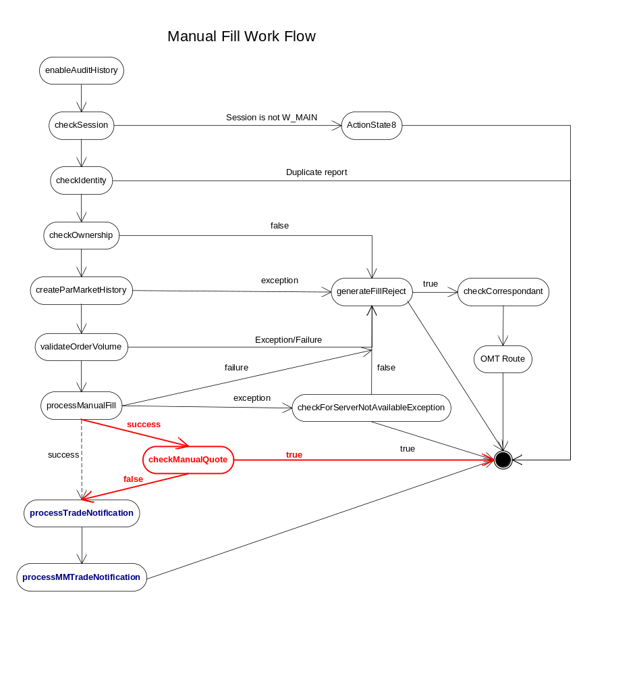

- Mark clearing type of PAR side of trade entry report as “IGNORE” when processing manual fill report of manual quote (TBD)
Following sequence diagram illustrates the design to passing the manual quote trade flag from OHS to TE when we process the manual fill for manual quote.
    - OHS receive manual fill from manual quote trade. The manual fill is processed by
MOMS.acceptManualFillReport method, which triggers the MaualFill_Workflow.
    - MaualFill_Workflow triggers WFStepAcceptManualFillReport work step.
    - In WFStepAcceptManualFillReport work step, we set manual report type of the manual file trade report to ‘Q’ (as defined in PAR_MANUL_QUOTE_CLEARING).
    - The manual report type of ‘Q’ is passed from OHS to TE through existing code.
    - When generating trade report, the manual report type of ‘Q’ is used to instruct the code to set the clearing type of the order that trades with manual quote to INGORE.
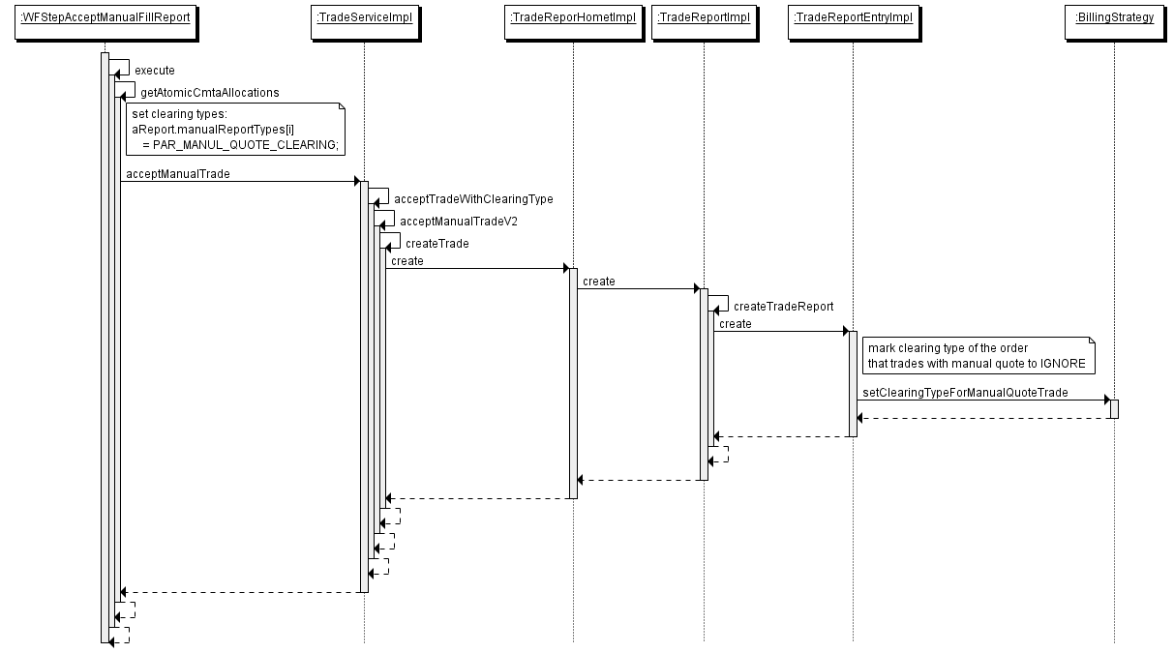

In the fill report sent to PAR, set the broker acronym of a contra-party of the manual quote to “XXP” if the contra-party is an order.
In OrderImpl.java, add a new overloading method of getClearingAcronym to accept a new parameter, isTradeWithManualQuote, which tells if the order trade with a manual quote. This method will return “XXP” as broker acronym if the order does trade with an manual quote.

public ExchangeAcronymStruct getClearingAcronym
(short tradeContext,
boolean isTradeWithManualQuote)

Update getBuyer()/getSeller() method to return “XXP” if the buyer/seller does trade with an manual quote.

Scripts
- None

Database
- None

SetContext

XML/DTD

Homes/Services

/server/Java/impls/com/cboe/businessServices/orderRoutingDestination/OrderHomeImpl.java

/server/Java/impls/com/cboe/businessServices/orderRoutingDestination/OrderImpl.java

/server/Java/impls/com/cboe/businessServices/tradeService/AtomicTradeImpl.java

/server/Java/impls/com/cboe/businessServices/tradeService/BillingStrategy.java

/ohs/integration/impls/com/cboe/ohs/workflow/steps/WFStepAcceptManualFillReport.java

/ohs/integration/impls/com/cboe/ohs/workflow/steps/WFStepCheckManualQuoteFileReport.java

/server/Java/impls/com/cboe/businessServices/tradeService/TradeReportEntryImpl.java

/server/domain_idl/constants.idl

/server/properties/xml/Order.xml

/ohs/properties/xml/workflows/ManualFill_Workflow.xml

PerformanceTestingProcedure
- .

TestingProcedure

OperatorProcedure
- .

Fallback/Failover

